**LAB 2**

**Exercise:**

**1. Explain the working of the Hill cipher. Encrypt the text "Hello World" with a key 𝐾 = [𝐶 𝐵 𝐷 𝐸]. What is the result?**

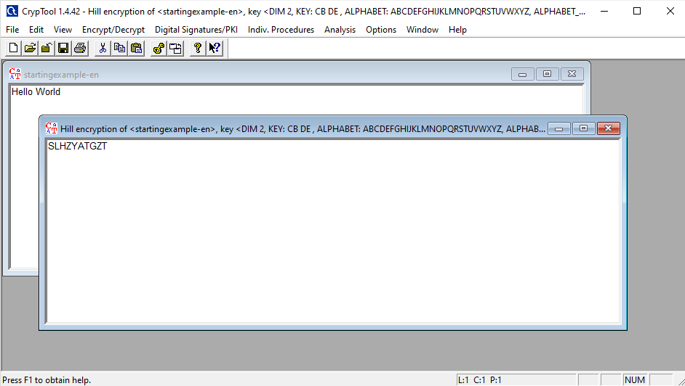

**2. Using analysis in Cryptool, apply the known plain text attack and find out the key of Hill Cipher. Known Plain Text “friday” and corresponding cipher text is “PQCFKU”**

